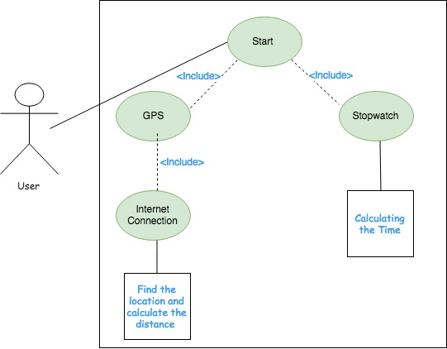

|  |  |
| --- | --- |
| Use Case Description | Created by Dorfam |
| Use Case Title: | Timer |
| Primary Actor: | User |
| Level: | Cloud |
| Stakeholders: | User / Customer |
| Precondition: | User must have access to UI before timer starts to function. |
| Minimal Guarantee: | Gives a null to calculator use case to prevent crashing. |
| Success Guarantees: | The timer gives times in sequential order in which they are produced to the calculator use case. |
| Trigger: | The user moves around. When movement is detected, the timer starts timing and sending each point in time to the calculator to process. |
| Main Success Scenario: | The timer will be feeding the calculator use case a series of times as inputs which will result with the calculator processing the data being received. |
| Extensions: | * Timer doesn’t work.   + Instead of giving no time, the timer will give a null value to prevent crashing the application. |